Mini c++ compiler

Group No-1

Group Members ::

RIT2009012
RIT2009048
RIT2009004

A compiler is a computer program (or set of programs) that transforms source code written in a programming language (the source language) into another computer language (the target language, often having a binary form known as object code). The most common reason for wanting to transform source code is to create an executable program.

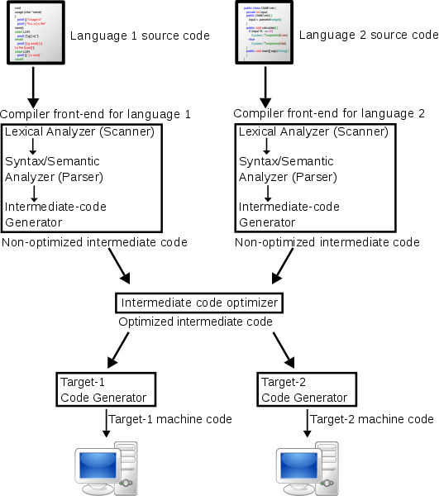

Lexical grammar
The specification of a programming language often includes a set of rules which defines the lexer. These rules usually consist of regular expressions, and they define the set of possible character sequences that are used to form individual tokens or lexemes.
In programming languages that delimit blocks with tokens (e.g., "{" and "}"), as opposed to off-side rule languages that delimit blocks with indentation, white space is also defined by a regular expression and influences the recognition of other tokens but does not itself contribute tokens. White space is said to be non-significant in such languages.

Token
A token is a string of characters, categorized according to the rules as a symbol (e.g., IDENTIFIER, NUMBER, COMMA). The process of forming tokens from an input stream of characters is called tokenization, and the lexer categorizes them according to a symbol type. A token can look like anything that is useful for processing an input text stream or text file.
A lexical analyzer generally does nothing with combinations of tokens, a task left for a parser. For example, a typical lexical analyzer recognizes parentheses as tokens, but does nothing to ensure that each "(" is matched with a ")".

Lexical Analysis

A lexical analyser or scanner is a program that groups sequences of characters into lexemes,
and outputs (to the syntax analyser) a sequence of tokens. Here:

(a) Tokens are symbolic names for the entities that make up the text of the program;
e.g. if for the keyword if, and id for any identiﬁer. These make up the output of
the lexical analyser.
(b) A pattern is a rule that speciﬁes when a sequence of characters from the input
constitutes a token; e.g the sequence i, f for the token if , and any sequence of
alphanumerics starting with a letter for the token id.

(c) A lexeme is a sequence of characters from the input that match a pattern (and hence
constitute an instance of a token); for example if matches the pattern for if , and
foo123bar matches the pattern for id.

Syntax Analysis

The second phase of a compiler is called syntax analysis. The input to this phase
consists of a stream of tokens put out by the lexical analysis phase. They are then
checked for proper syntax, i.e. the compiler checks to make sure the statements and
expressions are correctly formed. Some examples of syntax errors in C++ are..

// mismatched parentheses

// missing parentheses

// invalid keyword do

while (x==3) do f1();

When the compiler encounters such an error, it should put out an informative message for
the user. At this point, it is not necessary for the compiler to generate an object program.
A compiler is not expected to guess the intended purpose of a program with syntax errors.
A good compiler, however, will continue scanning the input for additional syntax errors.

Semantic Analysis

Parsing only verifies that the program consists of tokens arranged in a syntactically
valid combination. Now we’ll move forward to semantic analysis, where we delve even
deeper to check whether they form a sensible set of instructions in the programming
language. Whereas any old noun phrase followed by some verb phrase makes a
syntactically correct English sentence, a semantically correct one has subject-verb
agreement, proper use of gender, and the components go together to express an idea
that makes sense. For a program to be semantically valid, all variables, functions,
classes, etc. must be properly defined, expressions and variables must be used in ways
that respect the type system, access control must be respected, and so forth. Semantic
analysis is the front end’s penultimate phase and the compiler’s last chance to weed out
incorrect programs. We need to ensure the program is sound enough to carry on to
code generation.

A large part of semantic analysis consists of tracking variable/function/type
declarations and type checking. In many languages, identifiers have to be declared
before they’re used. As the compiler encounters a new declaration, it records the type
information assigned to that identifier. Then, as it continues examining the rest of the
program, it verifies that the type of an identifier is respected in terms of the operations
being performed. For example, the type of the right side expression of an assignment
statement should match the type of the left side, and the left side needs to be a properly
declared and assignable identifier. The parameters of a function should match the
arguments of a function call in both number and type. The language may require that
identifiers be unique, thereby forbidding two global declarations from sharing the same
name. Arithmetic operands will need to be of numeric—perhaps even the exact same
type (no automatic int-to-double conversion, for instance). These are examples of the
things checked in the semantic analysis phase.

Some semantic analysis might be done right in the middle of parsing. As a particular
construct is recognized, say an addition expression, the parser action could check the
two operands and verify they are of numeric type and compatible for this operation. In
fact, in a one-pass compiler, the code is generated right then and there as well. In a
compiler that runs in more than one pass (such as the one we are building for Decaf),
the first pass digests the syntax and builds a parse tree representation of the program. A
second pass traverses the tree to verify that the program respects all semantic rules as
well. The single-pass strategy is typically more efficient, but multiple passes allow for
better modularity and flexibility (i.e., can often order things arbitrarily in the source
program).
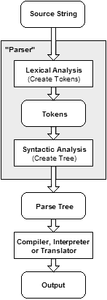

COMPILATION STEP

WHAT WE HAVE DONE:

The only basic types are boolean, character, string, integer, and real.

A variable name can consist of any combinations of letters, numbers, and the underscore(_). However, the first character in a variable must be a letter.

This language is case-sensitive.

Statements are evaluated from right to left, top to bottom, with each new statement on a new line.

Comments:

As with any good code, your files should be commented as well. Comments are of course not executed like normal languages. Multiline comments are surrounded by braces {}. Single line comments use the hash mark #. Comments should be written assuming that they will carry over into the code. Comments for variables passed in a function are required and indicated by a colon.

Operators:

Add (+)

Subtract (-)

Multiply (*)

Divide (/)

Modulus (%)

inc (++)

dec (--)

"<"

">"

"<="

">="

"=="

"||"

"&&"

"++"

"--"

">>"

"<<"

">>>"

"+="

"-="

"*="

"/="

"&="

"|="

"^="

"%="

"<<="

">>="

">>>="

PrimitiveType

bool

char

byte

short

int

long

float

double

void

Modifier

abstract

final

public

PROTECTED

PRIVATE

STATIC

TRANSIENT

VOLATILE

NATIVE

Input/Output

Input from a user is c++ file . Output for a user to read from the standard output is indicated by the keyword print or printLine followed by what you want to have displayed to the user. If there is an error our code prints to the standard error use the keyword printError.

Our code prints the message if the input cpp file consists any syntax error
If the input file contains no error and compiles perfect then there would be no error to display.

our compiler not identify
1. vector,map,queue,mulmap.

how to compile::

lex code.l

yacc –d code.y

gcc lex.yy.c y.tab.c –lfl

./a.out file.c/cpp

